Course: Web Application Development
Lab Instructor: Dr. Le Duy Tan
Email: ldtan@hcmiu.edu.vn

Lab 2: Advanced HTML and CSS

Contents:
- Objects:
- Form
- CSS
- Exercises

Duration: 3 hours

Part 1: Objects

In the HTML file, open source code and use the following objects below to create a webpage

- Textbox
<input type="text" name ="T1" size="33">

- Check-box
<input type="checkbox" name="c1" value="ON">Computer Graphic <br>
<input type="checkbox" name="c2" value="ON">Computer Network <br>
<input type="checkbox" name="c3" value="ON">Introduction to Computer<br>
<input type="checkbox" name="c4" value="ON">Web Programming<br>

- Radio
<input type="radio" value="r1" checked name="red">Red
<input type="radio" value="r2" checked name="blue">Blue
<input type="radio" value="r3" checked name="green">Green

- Button
<input type="submit" value="Submit" name="s1">
<input type="reset" value="Reset" name="s2">

- Combo-box
<select name="Type">
<option>Reading</option>
<option>Whatching TV</option>
<option>Studying</option>
<option>Shoping</option>
<option>Internet</option>
</select>

- Text-area
<textarea rows="number of rows" name="tr1" cols="number of columns"></textarea>

Part 2: design Form
A form is any section of a web page where a user can input information (though sometimes form elements are used to display information rather than collect it)

Example: This is source code of file InputPage.jsp
<html>
<head>
<meta http-equiv="Content-Type" content="text/html; charset=UTF-8">
<title>JSP Page</title>
</head>
<body>
<h2>Please Input The Value!</h2>
<form method="post" action="GetValue.jsp">
<input type="text" name = "tx1"><br>
<input type="Submit" value= “Submit”>
</form>
</body>
</html>
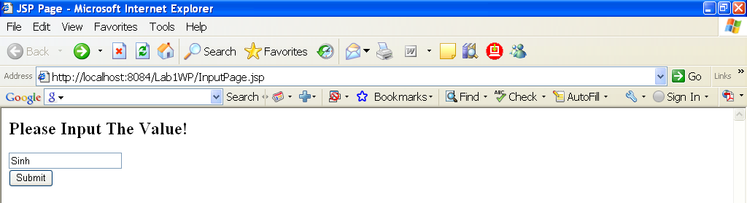

This is the source code of file GetValue.jsp
<html>
<head>
<meta http-equiv="Content-Type" content="text/html; charset=UTF-8">
<title>JSP Page</title>
</head>
<body>
<h2>Result page</h2>
<%
String value = request.getParameter("tx1");
out.print("Hello "+value+"!");
%>
</body>
</html>

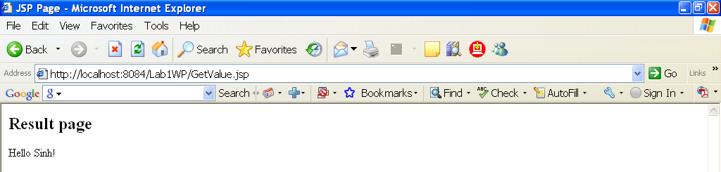

Exercise: You create a form like this:

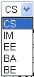
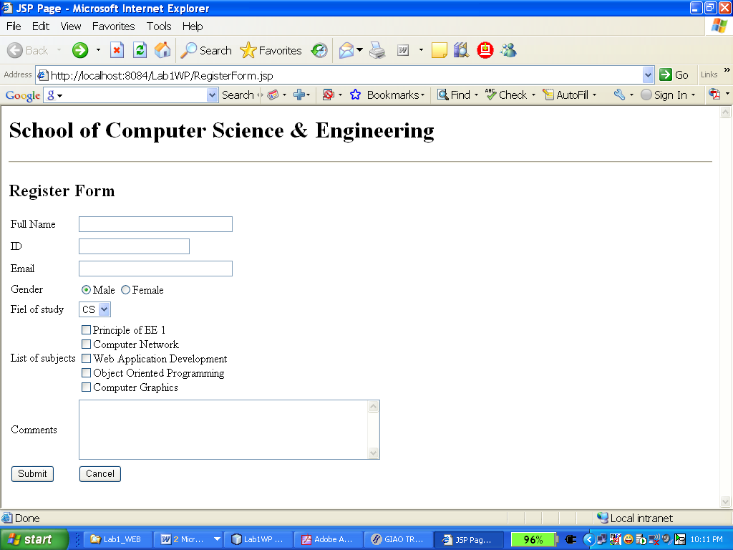
Text field
Radio
Combo-box
Text-Area
Check-box

After input information and click “Submit” button, the result like this:

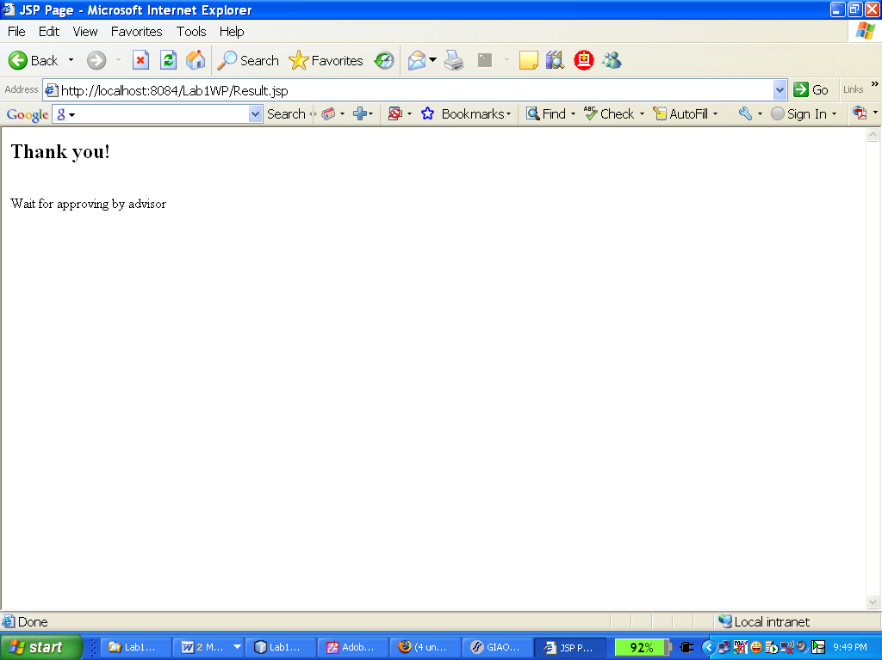

Part 3: CSS
CSS can add style to your pages, enhancing and improving the presentation of your content.
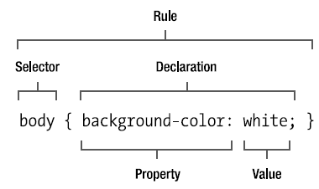
There are 3 types of CSS:
- External Style Sheet: It is declared and stored in the separate file, then can add and use in all the web pages of the website.
- Internal Style Sheet: It is declared on the header of web page and use for only this page.
- In - line Style Sheet: It is declared in the tag of HTML and use for this line.

Example of External Style Sheet:
<html>
<head>
<title>Spaghetti and Cruft : Our Menu</title>
<link rel="stylesheet" type="text/css" href="styles.css" />
</head>
<body>
<h2>Testing External Style Sheet</h2>
<p>This is the content of page </p>
</body>
</html>

This is the content of styles.css
h2 {font-size: 130%; color:red};
p {font-size: 120%; color:blue};

Example of Internal Style Sheet:
<html>
<head>
<STYLE TYPE = "text/css">
H1.titlepage {text-align: center;color: red }

</STYLE>
</head>
<body>
<H1 class=titlepage>Introduction!</H1>
<h2>Hello World!</h2>
<h3>This is lab section of Web Application Development</h3>
</body>
</html>
Example of In-Line Style Sheet:
P STYLE = “background:blue;color:red”>

Last exercices:
You have permission to reuse content and CSS in page: https://tuoitre.vn/chatgpt-vuot-xa-instagram-10-trieu-nguoi-dung-hang-ngay-chi-sau-40-ngay-ra-mat-20230129105450027.htm to design the page exactly as below figure but in simple html document. Copying document from tuoitre will get 0 mark. Notify me when you finish your work to get mark

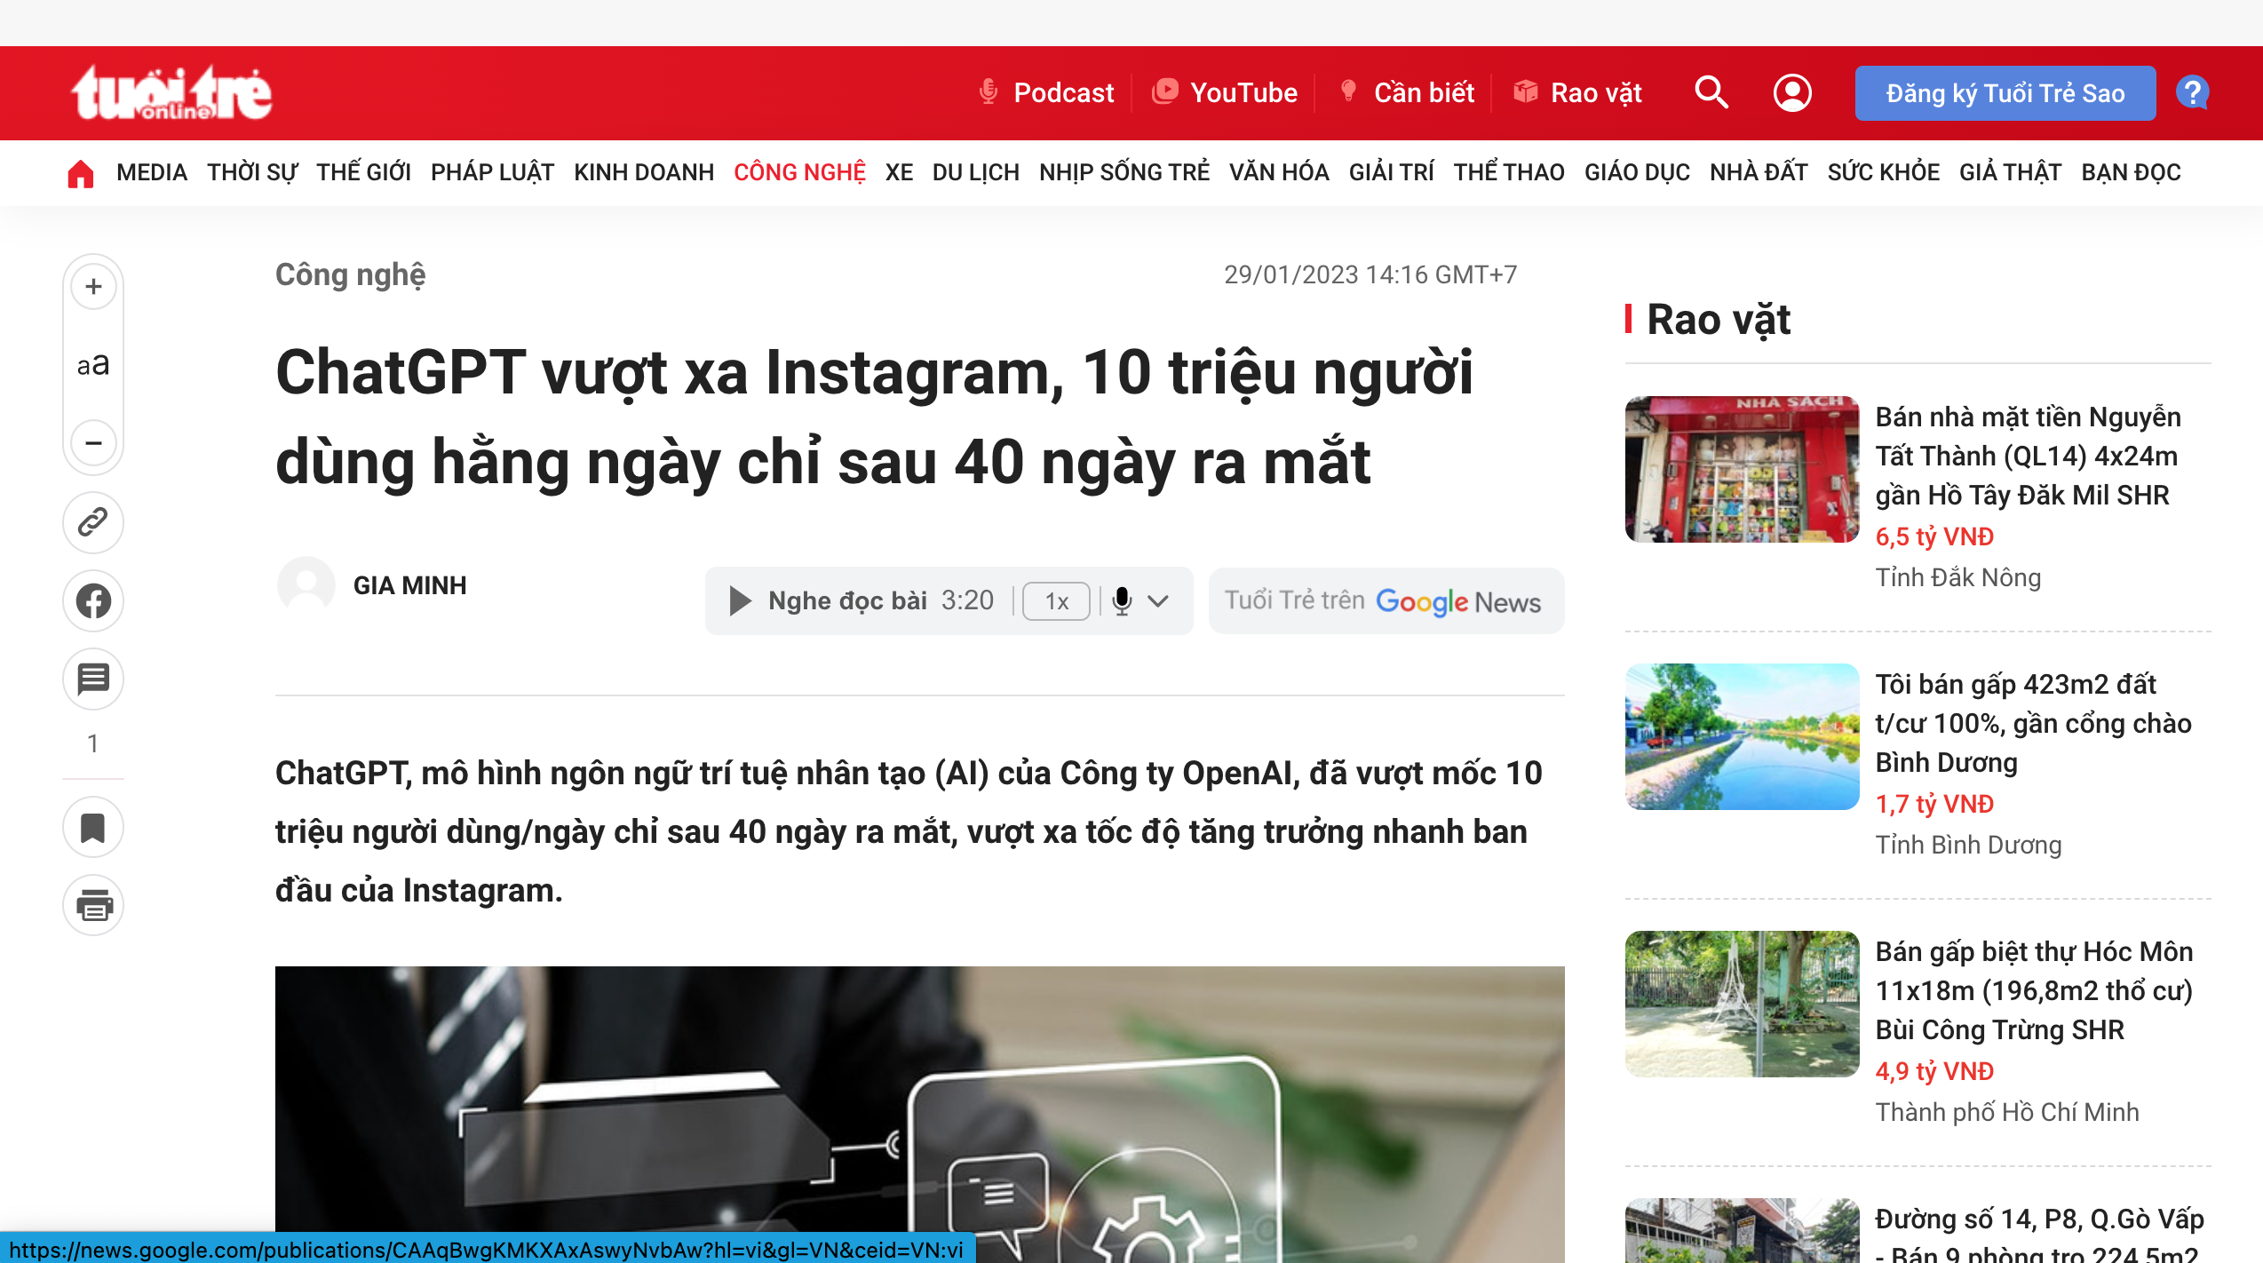

→ Go on to improve and finish Assignment 1 (if necessary)

